**DOT framework researches**

**Student:** Jorn Kersten

**Student number:** 483331

**Class:** DB-S3-DB03

Table of contents

**Geen inhoudsopgavegegevens gevonden.**

# DOT framework

## What is the DOT framework

The DOT framework is a research framework that helps answer ICT-related questions. The DOT framework helps to structure the research. The structure goes as follows: first comes the "What" of the research, then comes the "Why" of the research then follows the "How of the research". Below, I explain what these three parts mean.

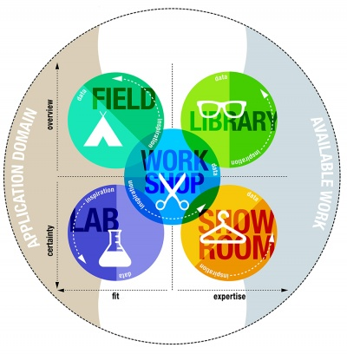

Figure 1

## The “What”

There are two different studies that can be done. One is the specific application context of the project and the other is a more general knowledge available that can help with a project. Both forms of research help and are necessary to create your own "innovation", your first new product or report. This can be expressed using three domains. The first domain is the "application domain". This is the domain of the specific context in which the ICT project takes place. The second domain is that of the "Available work". This uses all accessible theories, models and other artefacts that can be used from all currently available work. The third domain is the "Innovation domain". This is where the actual innovation takes place and all the under is done.

## The “Why”

It starts with getting on paper what you would like to research. This helps with creating a better structure to your research. If you are researching the context of your application, then the reason for your research is probably to obtain a product that is relevant to the stakeholders in the project. You are trying to optimize the **fit** between your product and the application context. Sometimes you want your product to conform to quality standards, in this case you are trying to make use of as much **expertise** available in the creation of your project. In both topics you use the "available work" domain (Figure 1, right column). You often use both research methods in these types of projects.

Similarly, there is a tradeoff between optimizing **overview** and **certainty**. Often, mostly in the beginning you want to gain a good overview about what is needed or what is available. At other times you want to test specific aspects of your work, making sure it works. In these cases you try to configure your research to optimize "certainty" about your hypotheses or goals.

## The “How”

During the project, the aim is to learn as much as possible about the context of available work, the application context and the innovation space. The DOT framework has 5 methods for this:

### Library (Top right of figure 1)

Library research is done to explore what is already done and what guidelines and theories exist that could help you further your design. Since the advent of the internet library research is also called desk research.

### Field (Top left of figure 1)

Field research is done to explore the application context. You apply a field strategy to get to know your end users, their needs, desires and limitations as organizational and physical contexts in which they will use your product.

### Lab (Bottom left of figure 1)

Lab research is done to test parts or concepts of your product, of the final product. You use lab research to learn if things work out the way you intended them, or to test different scenarios.

### Showroom (Bottom right of figure 1)

Showroom research is done to test your ideas in relation to existing work. Showing your prototype to experts can be a form of showroom research or spelling out how your product is different from the competition. Also testing your product to general guidelines is a form of showroom research.

### Workshop (middle of figure 1)

Workshop research is done to explore opportunities. Prototyping, designing and co-creation activities are all ways to gain insights in what is possible and how things could work.

## Source

<https://ictresearchmethods.nl/The_DOT_Framework>

# OWASP A07:2021-Identification and Authentication Failures

## Main question

The main question of this research is as follows: I would like to know how to prevent identification and authentication failures within my project.

## Chosen research method

I’m going to be using the [Community](https://ictresearchmethods.nl/Community_research) (library) research and the [Document analysis](https://ictresearchmethods.nl/Document_analysis) (field) research to reach my goal.

## Execution

### Possible Loophole in Authentication Workflow

### Client-Side Vulnerabilities

### The Problem

### Browser Storage

### Solutions according to Angular docs

### Sources

<https://cyolo.io/blog/identification-and-authentication-failures-and-how-to-prevent-them/>

<https://www.stackhawk.com/blog/angular-broken-authentication-guide-examples-and-prevention/>

<https://angular.io/guide/security>

## Results